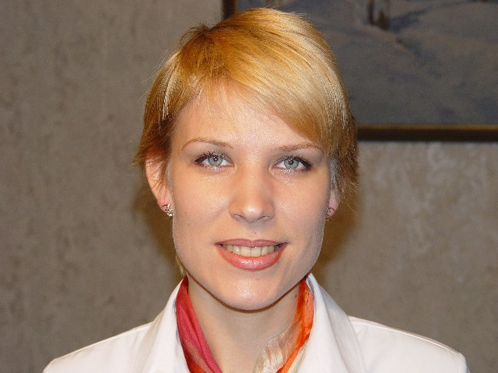
Romanova Olga Sergeevna graduated from Ammosov Yakutsk State University, Cand. of geogr. scien., junior researcher of Vavilov Institute of Natural Sciences and Technique History (IIET RAN), the department of The Earth Sciences History

MAPPING RESULTS OF THE EXPEDITION BY G.L.MYDEL TO YAKUT REGION IN 1868-1870

O.A. Lazebnik
Saint Peterburg State University
lazebniko@mail.ru

O.S. Romanova, S.I. Vavilov
Institute of the History of Sciences and Technology Russian Academy of Sciences
ol_r@mail.ru

Scientific literature usually mentions G.Mydel in connection with the Chukotka Expedition of 1868-1870, with its ethnographic studies, searches for remains of mammoth species, descriptions of permafrost processes. The G.L. Mydel’s chief scientific legacy is his work “Trip through North-East part of Yakut Region …” published by the Academy of Sciences in 1894-1896. We carry out a search for new records to throw light on Mydel’s mapping performance, which has not been yet the point of scientific studies.
27 March 1891 had witnessed baron Mydel’s work on his exploration and research in Yakut Region being presented by academician L.I. Shrenk at the meeting of the Imperial Academy of Sciences with his recommendation for it to be published [1]. At the beginning of his comprehensive speech the academician appraised the work as being “quite remarkable” and “of great help to afford an in-depth view of marginal lands in the North-East of our country”. The author was reported to have spent 24 years (from 1859 till 1883) in state service in the Eastern Siberia, including for more than decade in Yakut Region as an officer for special missions under the Region’s Governor, then as ispravnik (district police officer) of Kolyma and Olekma districts and, finally, as a member of provincial government and local statistic committee. The above capacities, L.I. Shrenk said, had allowed G. Mydel to become familiar with the whole Region through on-site visits and carry out research of the Region by using many sources, which otherwise were difficult to access. In giving a detailed assessment of the manuscript, L.I. Shrenk remarked that the whole work incorporates a number of interesting standalone parts, among which “however, the central role is certainly played by detailed critical review of all mapping materials available in respect of the Yakut Region as well as self produced mapping related to this vast country”. “It goes without saying, - summarizes the reviewer, - that all the maps and the rest of Mydel’s work are to be published”, and not only in Russian, but also in German.
The respected academician’s proposal was approved and in 1894, first in German and then in Russian, the volume one of Mydel’s work had come off the press, then in 1896 - the volume two with the atlas [2]. However, the author, who had to face numerous hardships not only in the course of actual exploration but also in preparing his work for edition, unfortunately had passed away before the time when the results of many years of his laborious scientific research were presented to general public.
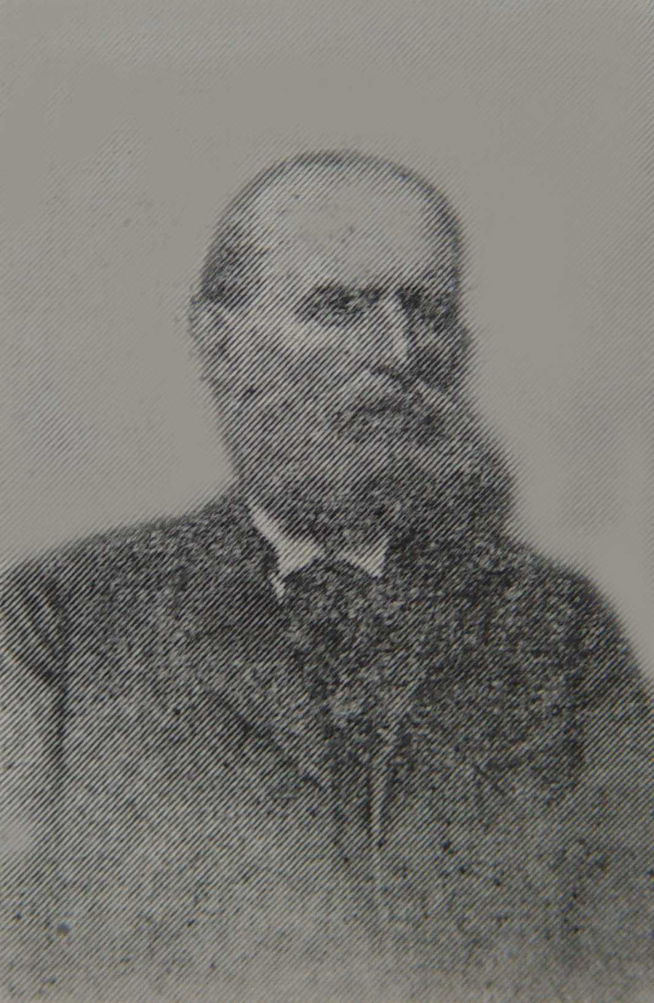
Gerhardt Gustav Ludwig von Mydel (Figure 1) was born on 19 April 1835 in the city of Derpt (Yuryev, Tartu). Family of barons von Mydel from Lifland province of Russian Empire was famous for its military officers, scientists and public servants. The young baron had a good education: he had finished a cathedral school in the city of Revel among the best and in 1854 was admitted to the Department of history and philology of the Derpt University [3, P. 269-270]. As far as the teaching staff is concerned, the University of Derpt of the first half XIX century was considered one of the best in Europe. Many of the University graduates became famous scientists and pubic servants of the Russian Empire of the time. For sure, the years of studies in the company of professors and his senior fellow students had inspired G. Mydel with affection for travels to explore remote countries. We have grounds to assume that a good example to follow was provided by A.F. Middendorf, the Derpt University graduate, who by the time had become a distinguished scientist [4]. In 1859 G. Mydel “had passed the final test, … while showing good knowledge in Russian” [the extract from 5, P. 93]. The same year, upon the recommendation of G.P. Helmersen, an academician of the Imperial Academy of Science and the Derpt University professor, G. Mydel had been admitted to the expedition to Siberia undertaken by the Imperial Russian Geographical Society (IRGO) where he was appointed assistant to the expedition astronomer Schwartz [6]. The expedition was led by F.B. Schmidt, who was also the Derpt University graduate. However, the serious disease of G. Mydel didn’t allow him to join the expedition. Mydel had reached only the city of Irkutsk, where he settled down upon recovery.
Figure 1 Gerhardt Gustav Ludwig von Mydel
(1835-1894)
In 1860 he entered public service as an officer for special missions under the Irkutsk civil Governor and then under the Yakut Region’s Governor [3, P. 270]. The Yakut Region’s civil Governor Yu.I. Shtubendorf, who had been also the Derpt University graduate and A.F. Middendorf’s mate and close friend [4], was known for his bent for explorations. He found in Mydel, who stood out as a well-educated person with the knowledge in different spheres, such as history, geography, zoology, geology, a responsible executive to perform special missions related to exploration of remote places in the territory under his rule. Thus, in 1862-1863 G. Mydel was sent to Olekma and Vilyuy districts to examine possibilities to move there peasant population and set up farming agriculture, and then in 1867 to Olekma district to acquaint himself with gold mining business. Special remark deserves G. Mydesl’s trip to Verkhoyansk and Kolyma districts in 1866 to examine administrative situation with the local population, whereby he was instructed to take steps to bring under the Russian rule the ethnic group of Chukchi, who were reputed as belligerent people.
As he spent many months being sent on missions, G. Mydel not only kept detailed records during his trips and collected actual data related to his missions; he also, on his own initiative, constructed route maps. His reports [7], which have survived, carry plenty of useful information and are very comprehensive, they testify to the Mydel’s true geographical attitude of mind. To recognize his contribution to Eastern Siberia exploration, in April 1868 G. Mydel was elected a full-fledged member of the Siberian Department of the Imperial Russian Geographical Society (SO IRGO), which was under the patronage of M.S. Karsakov, the Governor General [8].
The beginning of 1868 had seen G. Mydel being assigned with the mission of state importance – the Chukotka Expedition. The mission had decided his destiny since it allowed him to approve himself and brought him in contact with public officials of high standing and leading scientists of Russia. And this, in its turn, in the years that followed helped promote his career: after the expedition G.Mydel was appointed Procurator of Irkutsk and then Inspector General to supervise schools of Transbaikalia Region with the head office in the city of Chita. In 1883 G. Mydel with his family, which contained eight children, moved to Estland, where he continued his public service in the field of education. There, he set about the task of arranging materials collected over many years and related to the North-East territory of Russia, and preparing descriptive geographical work featuring a collection of maps. We are justified in assuming that G. Mydel gave a name to his work - “Trip through North-East part of Yakut Region in 1868-1870 …” - following the tradition of academy publications of the time in order to catch the attention of potential publisher – the Academy of Sciences, which had taken part in funding and arranging the Chukotka Expedition. However, also included in his “Trip …” were geographical data and topography assumptions acquired by the author during his mission trips undertaken in the 1860s, as well as the general map of the Yakut Region created after the Expedition, in the 1860-1870, based on different sources.
The serious disease he suffered in his youth, hard conditions of his mission trips and more than 2 years long expedition, where he experienced a lot of hardships, have undermined Mydels health. On 5 August 1894, when Mydel underwent medical treatment in Baden, he died. [3, P. 279].
The Chukotka Expedition was undertaken on the initiative of M.S. Karsakov, the Eastern Siberia Governor-General, and was the result of complicated political situation and the great interest the State had in far North-East of the country after the Alaska and Aleutian Islands had been sold to America, and also because transcontinental telegraph communications were supposed to be laid there [9, P. 6-7]. With the aim “to allow the state authorities have a close look at the Chukotka Territory and inhabiting it vagrant aborigines, known under the common name of Chukchi, … , and to form an idea about their way of life and the territory they inhabit, which are almost totally unknown”, M.S. Karsakov had recommended baron Mydel to fulfill the task, who was then a junior officer for special missions at the Eastern Siberia Chief Administration [10]. In his request to organize expedition, the Governor-General wrote: “the Chukotka territory deserves to be considered a true terra incognita in every respect …” [11, P. 4]. G. Mydel’s appointment as the expedition commander was decided not only because he had already been to Kolyma district in 1866, his personal merits were taken into account: wide range of knowledge, sociability, initiative and energy. The Ministry of Property Relations, which had supported the idea of the expedition and had defined the appropriate state assignment, suggested the Siberian Department of the Imperial Russian Geographical Society (SO IRGO) to assign the expedition with scientific tasks as well. The SO IRGO worked out the schedule for scientific research and found it possible to apply to the IRGO for help to outfit the expedition with necessary devices and tools. The IRGO, in its turn, suggested the Imperial Academy of Sciences (IAN) assist, within their powers, in outfitting the expedition with tooling, and also provide instructions how to collect scientific data [11, P. 3-5]. Both IRGO and IAN responded with interest and significantly extended the expedition mission. G. Mydel “displayed the desire to take upon himself the task of route survey and map composition” and the IRGO Council found it extremely important to attach to the expedition an experienced topographic surveyor from the Military-Topographic Department of the General Headquarters (MTD GH) [11, P. 5].
So, the Expedition was assigned with three chief tasks: the administrative one – to bring under the Russian rule nomadic tribes of the far North-East of the country and settle differences in relations between different clans and local authorities; the scientific one – to collect statistics, ethnographic data and nature-historical samples, carry out astronomical, magnetic and meteorological observations; the mapping – to perform topographic surveys over the places being visited and obtain a map of the territory.
To be up to its tasks, the expedition received funding from different sources: from the Treasury - 4337 rub. 38 kopeks, from SO IRGO - 1000 rub., from IRGO – 1 200 rub., and from General Headquarters - 500 rub. Total investments into the Expedition, as it had set out, amounted to 8 537 rub. [11, P. 6-7; 12, attachm]. In addition to it, in 1869 the Academy of Sciences provided funding in the amount of 1 500 rub. to search for mammoth remains [13]. As a whole, the spending on the Expedition reached 10 000 rub.
The Expedition was joined by: K.K. Neiman from SO IRGO to define locations with the use of astronomical tools, and carry out magnetic and meteorological observations; P. Afanasyev, the topographer from District Headquarters of the War Ministry, to perform topographic surveys and compile a map for reporting purposes; Antonovich, the medical attendant, who, in addition to his direct responsibilities, was to assist in sample collecting; and also Cossacks and guides. To testify to the great importance of the Expedition, we can mention the fact that lieutenant baron G. Mydel, who was just a junior kollezhsky sovetnik (the service grade in Russian Empire), in spring 1868 was urgently summoned from Yakutsk to Irkutsk, and then to Saint Petersburg (the Russian capital of the time), where he personally received instructions and completed preparations for the Expedition.
Thus, the Academy of Sciences, at the IRGO request signed by Count F.P. Litcke [14], had given to G. Mydel instructions prepared by academicians Brandt and Ruprecht on how to collect natural samples, questions from academician Behr, books [15] and tools [16] – magnetic theodolite produced by Krause, Schmalkalden’s surveying compass produced by Brauer, a mount as an accessory, and an inclination compass – to the total value of 564 rub. 7 kopeks altogether. As testified by the note of M. Rykachev, the head of the Central Physical Observatory, the tools were specifically adjusted and outfitted in Brauer’s workshop and then, after being checked and tested, on June 4, 1868 handed over to G. Mydel to be used during the Expedition.
The Expedition was scheduled to set out from Yakutsk in autumn 1868 and return back to Yakutsk in summer 1870. However, being exposed to different natural calamities (snowstorm, spring floods, lack of fodder for transport livestock, aphtha epidemics etc.), the Expedition reached Yakutsk in late autumn 1870, and arrived to Irkutsk only in the beginning 1871.
The Chukotka Expedition was kept track of in the IRGO and SO IRGO Reports for 1869-1871, where it was referred to as an important scientific event. In 1871, Mydel’s letters with related comments were published in the Notes of the Academy of Sciences (Vol. XVIII, XIX, XX), in the Bulletin de Academie (V. XVI). The RGO Archive has preserved Mydel’s handwritten report prepared in Yakutsk before the Expedition was finished [17].
In Irkutsk, after “the greetings of Laborers of Science” a dispute rose: SO IRGO insisted on reimbursement of expenses incurred by the Expedition and demanded that full report was to be promptly submitted together with all samples and mappings obtained by the Expedition, whereas G. Mydel kept to the opinion that the samples needed to be transferred to Saint Petersburg to undergo scientific analysis as soon as possible [18]. In spring 1871 in Irkutsk, G. Mydel succeeded in persuading the provincial government that he needed to be sent to Saint Petersburg to personally deliver mammoth’s remains that had been discovered on the order of the Academy of Sciences. In June 1871 he reached the capital where he attended the IRGO and the Academy of Sciences and passed over to the Academy’s Museum of Zoology two mammoth’s legs [19], and, possibly, other findings. The Academy, however, refused to reimburse Mydel’s expenses on his trip from Irkutsk to Saint Petersburg having considered the reason for his arrival insufficient [20]. We are justified in assuming that during that visit G. Mydel met his former fellow students from Derpt – academicians L. Shrenk and F. Schmidt and, possibly, took their advice to provide the description of the Expedition in the form of a “Trip …” with the atlas.

In the course of the Chukotka Expedition, mapping activities took a large amount of work, becoming especially extensive when the whole team stayed together. P. Afanasyev had surveyed 6 routes [21], which took up 53 sheets. As it was later noted in the Report of SO IRGO, they “… to some degree completely change what used to be our idea about geographic features of Chukotka territory” [18, P. 10-11]. The surveys were executed at a scale of 12½ versts (1.0668 km) in 1 inch. G. Mydel performed numerous checks to ensure data quality. He highly apprized the work of the topographer: “Mr. Afanasyev was very diligent in his work and, besides the routes surveyed with the use of the azimuth compass, he has collected many valuable data by way of questioning aborigines, so the fluvial systems of Yana, Indigirka, and Kolyma rivers can be considered as quite satisfactory explored. The same can be said about Verkhoyansk Range and its northern spurs” [22]. Less satisfied the expedition commander appeared to be with the astronomer K. Neiman’s performance: “ … he made observations at any favorable opportunity, however, in the end there were not so many of them” [23]. K. Neiman explained his inability to carry observations by low winter temperatures (“tools heated in yurt (nomads tent) get frozen too fast …”), winds, cloudy weather and soil instability in summer [24] Very disappointed G. Mydel appeared with the fact that K. Neiman and P. Afanasyev, when on their way back from Verkhnekolymsk to Yakutsk, arrived at the Aldan river not by following the new route through unexplored country, as it had been planned, but instead passing well known path while not making any route surveys. However, as early as the end 1870 P. Afanasyev compiled the reporting map of the expedition at a 50 versts scale and sent it to the IRGO [18, P. 13-14.]
Being in Saint Petersburg in 1871, G. Mydel had probably made acquaintance with O. Shtubendorf, the head of the Cartographic Establishment at the MTD GH, who was also the president of the Mathematical Geography Department of the IRGO [25]. Possibly, it was then that G. Mydel for the first time presented mapping materials obtained during the Expedition in hoping that they “would be of great help and provide the Eastern Siberia map of the General Headquarters with significant details as far as those places visited by the Expedition are concerned” [26].

After the Expedition, mapping activities of G. Mydel included acquisition and thorough analysis of mapping and geographical materials related to North-East Asia. The researcher had set a goal for himself to compile the most true and precise map of the territory, the largest part of which was taken up by Yakut Region. “We believe, - G. Mydel wrote, - … that we need to not only create a new map of the Yakut Region, but also furnish it with the explanatory note that would on the one hand disclose sources the map is based on, and on the other hand provide data, which would allow judgment to what extent the map can be trusted” [2, P. 34]. In estimating to what extent the territory had been explored from the point of view of geography and mapping reliability, G. Mydel wrote: “ … our current data related to Yakut Region are so scanty and incomplete that now we are hardly in the right to put them on paper and call it the detailed picture” [the same, P. 35].

G. Mydel performed a thorough revision of the preceding mapping works in an attempt to give them an objective evaluation. During his research, he made use of his connections with the Military-Topographic Department of the General Headquarters. The existence of communications between G. Mydel and O. Shtubendorf is evidenced by the letter of 8 April 1882 that has survived, in which the general notifies that he had sent to G. Mydel two North-East-related sheets of the 100-verst Asiatic Russia map published by the Military-Topographic Department. “These sheets, - O. Shtubendorf wrote, - underwent thorough revision based on those most valuable data that you had provided me with in your letter of 3 December 1878” [27]. The above mentioned 8-sheet Asiatic Russia Map was published in 1884, however, even this map in Mydel’s opinion was unable to provide “desired completeness and reliability”, what was the reason for him to go on with his mapping work.
In 1890, from snippets of information obtained from different sources, G. Mydel compiled fairly unique maps: “General Map of the Yakut Region” (Figure 2) and “Map of Astronomical Points determined on both coordinates and Journeys undertaken in the Yakut Region” (Figure 3). Based on these maps G. Mydel compiled an atlas, where, besides the maps, he also included classed catalog of rivers and the following large-scale plans: “Lacustrine territory between the rivers Kolyma and Bolshaya Kovchech (Ulkhan Khomos Yryakh) and along the left bank of Kolyma river”, “Lacustrine territory between the rivers Uyandina and Selengnya-Khom”, and “Map of taryns (ice fields) along the rivers Kyra and Nyekharan” (Figure 4) constructed by P. Afanasyev. The atlas presented in the form a separate sketchbook with a title page was to become an integral part of the Volume Two of the “Trip …”.
In 1891, the Academy of Sciences commissioned the Ilyin’s Cartographic Establishment in Saint Petersburg to publish the maps in quantity sufficient to complete the “Trip …” both in Russia and German. The publishing office provided a cost estimate in the amount of 1767 rub. and agreed to payment by installments over two years [28]. When finishing his work on Volume Two, G. Mydel decided to complete the atlas with yet another map – “Comparison of topographer Afanasyev’s route with that of I.D. Chersky”. In the end, total spending on publishing the maps amounted to 1945 rub. [29].
The Volume Two of the “Trip … with the Atlas featuring 4 maps and the classed catalog of rivers” was published in 1896. It was the first comprehensive and detailed description of the Yakut Region and adjacent territories. Although rather small in size, the Atlas is extremely valuable since it incorporates the most complete and reliable data, available at the time, related to Yakut Region. It had significantly extended the knowledge about the territory of the North-East Russia.
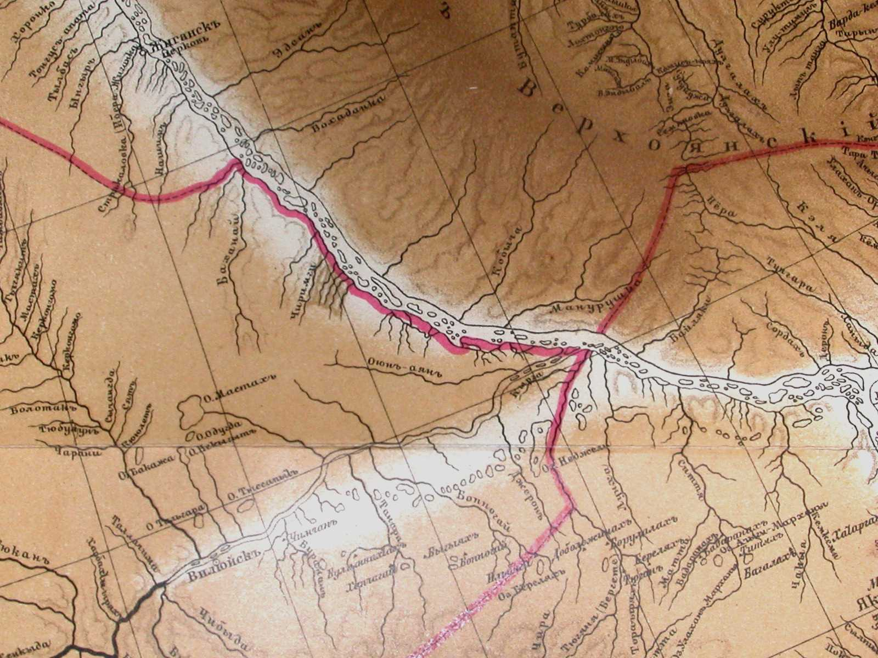
Figure 2 Part of the “General Map of the Yakut Region” 1896 [2]
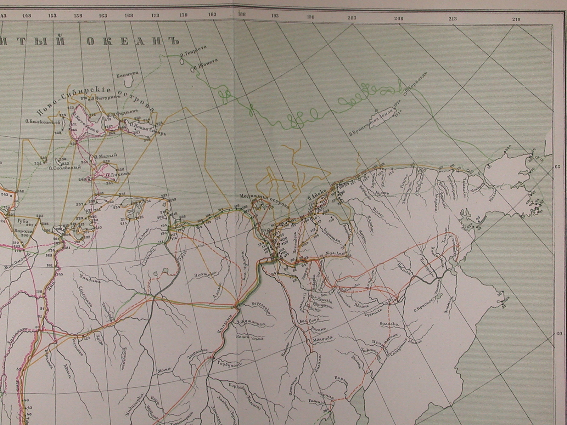
Figure 3 Part of the “Map of Astronomical Points determined on both coordinates and Journeys undertaken in the Yakut Region” 1896 [2]
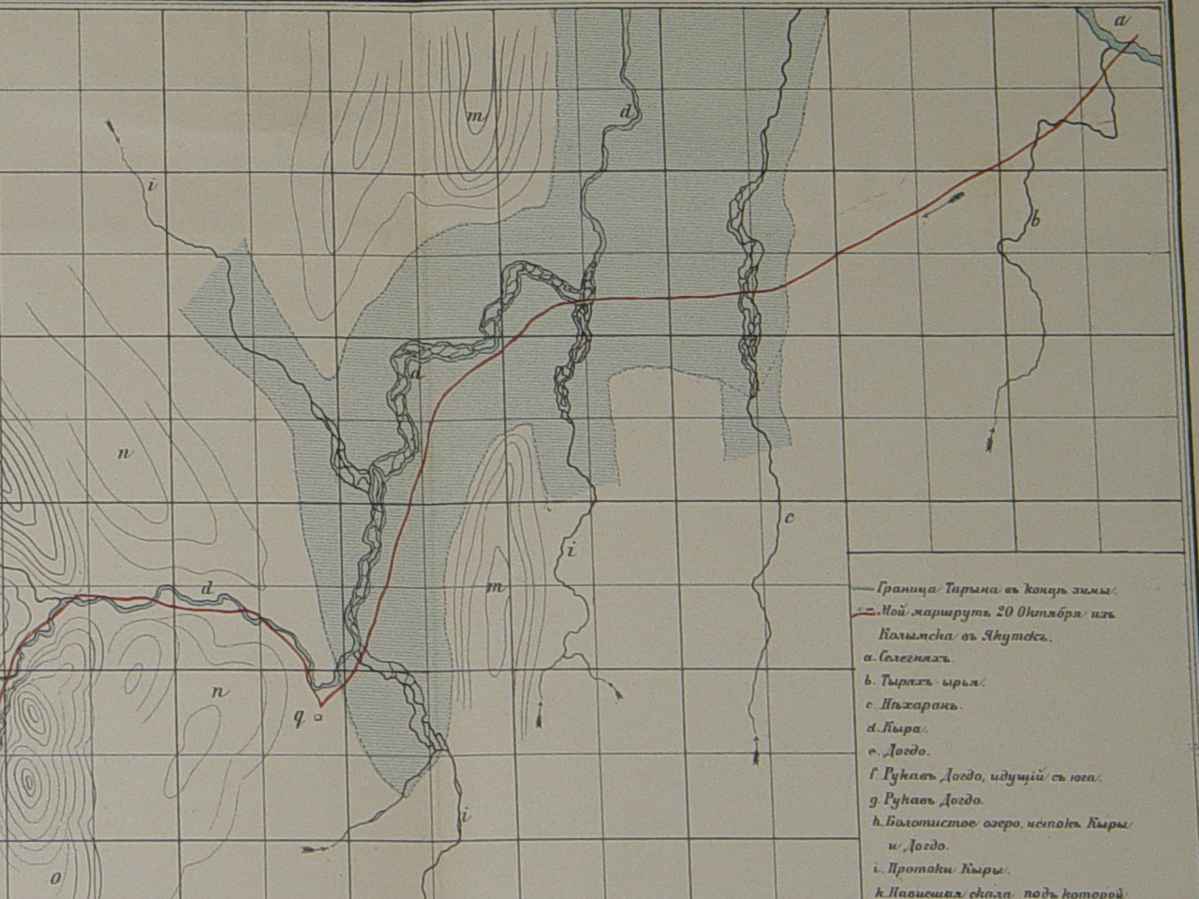
Figure 4 Part of the “Map of taryns (ice fields) along the rivers Kyra and Nyekharan” 1896 [2]
The “General Map of the Yakut Region” is the chief map in the Atlas and it had remained the only one reliable source of data for this extremely vast country right up until the second quarter XX century, when first systematic instrumental mapping surveys were carried out. This map is to be used in conjunction with the classed catalog of rivers grouped according to basins, since “it proved impossible to put on the map all river names”. As far as the number of rivers shown in the map and listed in the classed catalog is concerned, the G. Mydel’s work is far ahead of all preceding such works.
The author thought that available altitude-related data were too scanty to allow the detailed ground representation on the general map. However, he did his best to use the available data to the full “in order to, after all, disprove the theory, which treats on the Siberia-wide lowland and is now and then referred to in some works, and prove that although Western Siberia is mostly lowland country, the Eastern one, on the contrary, is mainly taken up by mountains and has considerable absolute elevation”. At first, an eight-level scale of height was supposed to be used, however, due to lack of funds it was decided to manage it with just four. This, G. Muydel thought, although made it possible to give “the right idea about the country with its peculiar high plateaus, but the relative altitude of different locations was presented not quite satisfactory” [2, P.74].
In order to demonstrate the reliability degree of the Yakut Region General Map, G. Mydel had compiled the “Map of Astronomical Points determined on both coordinates and Journeys undertaken in the Yakut Region”. The map shows all known at the time astronomical points and routs of explorers, who took measures and performed observations and surveys [same, P.134]. G. Mydel incorporated data on 276 points into the General Corpus of Astronomical Points of the North-East Asia Among them, there were those, which had been under observation of distinguished explorers – Islenyev, A Krasilnikov, I. Kruzenshtern, F. Litcke, P. Anjou, F. Wrangel, icluding 15 points determined by P. Afanasyev, 9 – by G. Mydel, and 6 – by K. Neiman. The map shows many routs starting with the one followed by the expedition of I. Billings and G. Sarychev (1786-1794) and ending with the expedition to the New Siberian Islands (1885-1886) led by A. Bunge and E. Toll. Also shown on the map are the routs G. Mydel followed when on his mission trips during 1862-1870.
The documents, which have thrown light on certain periods in Mydel’s many-years activities, prompt us to say some words about his patrons and associates, who made it possible to achieve the above mentioned results. Thus, Count F.P. Litcke, President of the Academy of Sciences and President of the IRGO, was the one, who personally dealt with many issues to organize the Chukotka Expedition, he also presided over the meetings, where reports received from the Expedition were discussed, the fact that certainly helped to recognize the importance of its results; M.S. Karsakov, the Eastern Siberia Governor-General and Patron of the SO IRGO, was the one who had seen through G. Mydel, then the yang officer for special missions, and recommended him to be appointed the commander of the Chukotka Expedition;Yu.I. Shtubendorf, the Derpt University graduate, in 1860s the Governor of the Yakut Region, he made it possible for G. Mydel to prove himself in civil service as a highly educated and energetic person; O.F. Shtubendorf, the head of the Cartographic Establishment at the MTD GH in 1867-1897, professor of Geodesics at the Nikolayevskaya Academy of the General Headquarters, president of the Mathematical Geography Department and the RGO council member, he contributed to the practical application of the mapping results obtained by the Chukotka Expedition what helped G. Mydel to earn authority among distinguished cartographers; L.I. Shrenk, the Derpt University graduate, academician, an author of numerous scientific works, including those related to the Amur river basin, the founder of the Anthropo-Ethnographic Museum at the Academy of Sciences, awardee of the Konstantinovskaya medal of the IRGO, he reported the progress of the Chukotka Expedition at the meetings of the Physico-Mathematical Department of the Academy of Sciences, he recommended G. Mydel’s work for publication and was the editor of its German edition. For sure, G. Mydel had associates, colleagues, and aids, who also made their contributions in the maps creation, although their names and roles are still unknown to us.
Summary: G. Mydel, while being on public service, for more than 30 years on his own initiative collected, analyzed and generalized mapping and geographical materials. Executed either by him personally or under his control, surveys related to remote and unexplored territories and compiled maps represent a considerable contribution in geographic exploration of the North-East Russia in the second half XIX century. His comprehensive geography-cartographic work covers the country taken up by todays Republic of Sakha (Yakutia) and the Chukot Autonomous Area; this work signaled the end of the time when mapping had been carried by way of questionings, by-sight-estimations and use of primitive tooling. The name of Gerhardt Gustav Ludwig von Mydel, as distinguished explorer and cartographer, must become the part of the history of the North-East Russia geographic exploration.

References
- Sankt-Peterburgskiy filial Arhiva Rossiyskoy akademii nauk (Department of Sankt-Peterburg Archive Russian Academy of Sciences, further PFA RAN). F.1. Op.1a. D.138. L.58-59. F. 2. Op. 1-1891. D. 16. L. 13-14.
- Mydel G.L. Puteshestvie po Severo-Vostochnoi chasti Yakutskoi oblasti v 1868-1870 godah barona Gergarda Mydelya. T.II s Atlasom, soderzhashcim 4 karty I sistematicheskiy spisok rek. SPb. 1896.
- Alekseev A.I. Syny otvazhnye Rossii. Magadan., 1970. 367 p.
- Sukhova N.G., Tammiksaar E. Aleksandr Fedorovich Middendorf. 1815-1894. Moscow: Nauka, 2005. 329 p.
- Shirina D.A. Letopis’ expedisiy Akademii nauk na severo-vostok v dorevoluchionnyi period. Novosibirsk: Nauka, 1983. 136 p.
- Arhiv Russkogo Geograficheskogo obschestva (Archive Russian Geographical Society, further ARGO). F.65. Op.1. D.22. L.3.
- PFA RAN. F.1053. Op.2. D.32, 33.
- Otchet o deyatelnosti Sibirskogo otdela Imperatorskogo russogo geograficheskogo obschestva za 1868 god [Report on the Siberian Department of the Imperial Russian Geographical Society activities over 1868]. SPb, 1869. 282 p.
- Shirina D.A. Expedicionnaya deyatelnost’ Akademii nauk na severo-vostoke Azii v 1861-1917 g. Novosibirsk: Nauka, 1993. 206 p.
- PFA RAN. F.4. Op.2-1869. D.87. L. 4.
- Otchet IRGO za 1869 g. SPb., 1870. 86 p.
- Otchet IRGO za 1870 g. SPb., 1871. 140 p.
- PFA RAN. F. 2. Op.2-1869. D. 9.-22 p.; Op. 1-1869. D. 87. – 11 p.
- PFA RAN. F.1. Op.1a-1868. D. 116. L. 66; Op. 2-1868. D. 21. L. 19-20.
- PFA RAN. F.1. Op.2-1868. D. 22. L. 19; Op. 1a-1868. D. 116. L. 66, 69.
- PFA RAN. F.1. Op.2-1868. D. 23. L. 47-50; Op. 1a-1868. D. 116. L. 71-ob.
- ARGO. Razr. 76. Op. 1. #12. – 17 p.
- Otchet Sibirskogo Otdela IRGO za 1871 g. SPb., 1872. 68 p.
- PFA RAN. F.2. Op.1-1869. D. 9. L. 19.
- PFA RAN. F.1. Op. 1a-1871. # 119; F. 2. Op. 1-1869. # 9. L. 20.
- ARGO. Razr. 76. Op. 1. # 12. L. 13- ob.
- ARGO. Razr. 76. Op. 1. D. 12. L. 14 - ob.
- ARGO. Razr. 76. Op. 1. D. 12. L. 13 - ob.
- Neiman K.K. Istoricheskiy obzor deistviy Chukotskoy expeditschii // Izvestiya Sibirskogo otdela IRGO. T. 1, # 4-5; T. 2. # 3. Irkutsk. 1871.
- Sergeev S.V., Dolgov E.I. Voennye topography russkoy armii. Moscow. 2001. 592 p.
- ARGO. Razr. 76. Op. 1. # 12. L. 14 - ob.
- PFA RAN. F.1053. Op.2. D. 28. L. 1-ob.
- PFA RAN. F.1. Op. 1a-1894. D. 138. L. 59.
- PFA RAN. F.1. Op. 1a-1894. D. 138. L. 59; D. 141. L. 157 - ob.

